**Broadway-Manchester**

|  |
| --- |
| Overview |

This report describes the demographic profile of Broadway-Manchester community, defined by First5 LA’s Best Start initiative. Overall, the purpose of this report is to assist local councils in determining outreach and engagement goals to achieve representation of current demographics of the community, as well as identify potential community needs.

All data in this report is from 2018 5-Year Estimates of the American Community Survey, an ongoing survey conducted by the U.S. Census Bureau. The geography of Broadway-Manchester is defined by census tracts provided by First 5 LA as part of the initial initiative planning in 2010. In order to provide some context, Broadway-Manchester data was compared with that of LA County to highlight both potential inequities and a further need for systems change efforts.

|  |
| --- |
| Demographics of Broadway-Manchester |

Broadway-Manchester is a South LA Best Start community of 88,863 people across a total of 18 census tracts. The following charts show the composition of sex, age, race/ethnicity and education for Broadway-Manchester residents.

|  |  |  |  |
| --- | --- | --- | --- |
| Table 1. Demographics Comparison Between Broadway-Manchester and LA County: | | | |
| Sex | | |  |
|  | **Broadway-Manchester** | **LA County** | **Net Difference** |
| Male | 47% | 49% | -2% |
| Female | 53% | 51% | +2% |
| Age | | |  |
|  | **Broadway-Manchester** | **LA County** | **Net Difference** |
| Under 5 | 9% | 6% | +3% |
| 5-17 | 22% | 21% | +1% |
| 18-64 | 61% | 65% | -4% |
| 65+ | 8% | 14% | -6% |
| Race-Ethnicity | | |  |
|  | **Broadway-Manchester** | **LA County** | **Net Difference** |
| Black | 26% | 8% | +18% |
| Latinx | 71% | 49% | +22% |
| White (Non-Latinx) | 1% | 26% | -25% |
| Asian | 1% | 15% | -14% |
| Latinx Origin (Top 3)[1] | | |  |
| Mexican | 72% | 76% | -4% |
| Salvadoran | 16% | 9% | +7% |
| Guatemalan | 7% | 6% | -1% |
| Citizenship | | |  |
|  | **Broadway-Manchester** | **LA County** | **Net Difference** |
| U.S. Citizen, born in the U.S. | 67% | 65% | +2% |
| U.S. Citizen, naturalized | 9% | 18% | -9% |
| Not a U.S. Citizen | 23% | 17% | +6% |
| Education | | |  |
|  | **Broadway-Manchester** | **LA County** | **Net Difference** |
| Less than High School | 42% | 21% | +21% |
| High School | 28% | 21% | +7% |
| Some College | 24% | 26% | -2% |
| Bachelor’s | 5% | 21% | -16% |
| Post-graduate | 1% | 11% | -10% |

**Key Takeaways**

* There is a larger proporition of Black and Latinx residents in Broadway-Manchester than that of LA County. In addition, there is a smaller proportion of White and Asian residents compared to that of the county
* Latinx and Black residents are the two largest groups in Broadway-Manchester, respectively
* The majority of the Latinx community is Mexican (72%), with the next two groups being Salvadoran (16%) and Guatemalan (7%).
* The majority of Broadway-Manchester are U.S. citizens born in the U.S. (67%) and at a greater proportion than that of LA County (65%)
* There are less naturalized U.S. citizens (9%) and a greater amount of noncitizens (23%) in the community than LA county (18% and 17%, respectively)
* There are less residents in Broadway-Manchester that have achieved some form of college experience (24%), a Bachelor’s degree (5%) and a Post-Graduate degree (1%) than in LA county

|  |
| --- |
| Economics of Broadway-Manchester |

|  |  |  |  |
| --- | --- | --- | --- |
| Table 2. Economics Comparison Between Broadway-Manchester and LA County | | | |
| Median Income | | |  |
|  | **Broadway-Manchester** | **LA County** | **Net Difference** |
| All Households | $37,890 | $72,797 | -$34,907 |
| White | $43,611 | $92,457 | -$48,876 |
| Black | $28,576 | $52,136 | -$23,560 |
| Asian | $59,464 | $86,544 | -$27,080 |
| Latinx | $44,516 | $61,174 | -$16,658 |
| Poverty Level | | |  |
|  | **Broadway-Manchester** | **LA County** | **Net Difference** |
| Below Poverty Level | 29% | 13% | +16% |
| At or Above Poverty Level | 71% | 87% | -16% |
| Unemployment Rate | | |  |
|  | **Broadway-Manchester** | **LA County** | **Net Difference** |
| Unemployment Rate | 9% | 5% | +4% |

**Key Takeaways**

* The median income in Broadway-Manchester is a little over 50% that of LA County’s median income
* Across all ethnic and racial groups in the community, the median income is lower than that of LA county
* There are a greater number of residents below the poverty level in Broadway-Manchester (29%) versus LA County (13%)
* The unemployment rate is higher (9%) than that of LA County (5%).

|  |
| --- |
| Families and Children of Broadway-Manchester |

|  |  |  |  |
| --- | --- | --- | --- |
| Table 3. Comparison of Families and Children Among Broadway-Manchester and LA County | | | |
| Total Families with Children under 6 | | |  |
|  | **Broadway-Manchester** | **LA County** | **Net Difference** |
|  | 1,292 | 183,314 | -- |
| Children under 6 by Family Arrangement | | | |
| Living with one parent | 36% | 37% | -1% |
| Living with two parents | 64% | 63% | -9% |
| Language Spoken in Household for Children 5-17 | | |  |
|  | **Broadway-Manchester** | **LA County** | **Net Difference** |
| English | 33% | 45% | -12% |
| Spanish | 67% | 45% | +22% |
| Other | 1% | 9% | -8% |
| Language Spoken in Household for Adults 18+ | | | |
|  | **Broadway-Manchester** | **LA County** | **Net Difference** |
| English | 36% | 43% | -7% |
| Spanish | 63% | 38% | +25% |
| Other | 1% | 19% | -18% |

|  |
| --- |
| Housing for Broadway-Manchester |

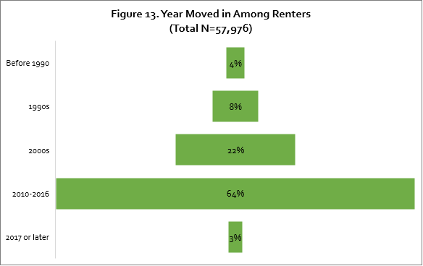

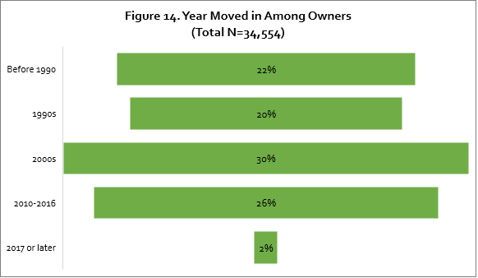

|  |  |  |  |
| --- | --- | --- | --- |
| Table 4. Comparison of Housing Among Broadway-Manchester and LA County | | | |
| Ownership of Occupied Units | | |  |
|  | **Broadway-Manchester** | **LA County** | **Net Difference** |
| Owner | 37% | 45% | -8% |
| Renter | 63% | 55% | +8% |
| Established Owners by Time Period | | | |
|  | **Broadway-Manchester** | **LA County** | **Net Difference** |
| Before 1990 | 22% | 22% | 0% |
| 1990s | 20% | 20% | 0% |
| 2000s | 30% | 30% | 0% |
| 2010-2016 | 26% | 26% | 0% |
| 2017 or later | 2% | 2% | 0% |
| Established Renters by Time Period | | | |
|  | **Broadway-Manchester** | **LA County** | **Net Difference** |
| Before 1990 | 4% | 3% | +1% |
| 1990s | 8% | 7% | +1% |
| 2000s | 22% | 18% | +4% |
| 2010-2016 | 64% | 40% | +24% |
| 2017 or later | 3% | 32% | -29% |

**Key Takeaways**

* There is a lower rate of homeownership in Broadway-Manchester (37%) compared to that of LA County (45%).
* About 75% of homeowners in Broadway-Manchester moved there before 2010
* The majority of renters (64%) moved into a residence in Broadway-Manchester between 2010-2016

1. Disaggregation of other communities available upon request