**Compton-East Compton**

|  |
| --- |
| Overview |

This report describes the demographic profile of Compton-East Compton community, defined by First5 LA’s Best Start initiative. Overall, the purpose of this report is to assist local councils in determining outreach and engagement goals to achieve representation of current demographics of the community, as well as identify potential community needs.

All data in this report is from 2018 5-Year Estimates of the American Community Survey, an ongoing survey conducted by the U.S. Census Bureau. The geography of Compton-East Compton is defined by census tracts provided by First 5 LA as part of the initial initiative planning in 2010. In order to provide some context, Compton-East Compton data was compared with that of LA County to highlight both potential inequities and a further need for systems change efforts.

|  |
| --- |
| Demographics of Compton-East Compton |

**Compton-East Compton Focus**

Compton-East Compton is a South LA Best Start community of 134,096 people across a total of 28 census tracts. The following charts show the composition of sex, age, race/ethnicity and education for Compton-East Compton residents.

**Compton-East Compton Compared to LA County**

The following table compares demographics of Compton-East Compton across sex, age, race/ethnicity and education with LA County.

|  |  |  |  |
| --- | --- | --- | --- |
| Table 1. Demographics Comparison Between Compton-East Compton and LA County: | | | |
| Sex | | |  |
|  | **Compton-East Compton** | **LA County** | **Net Difference** |
| Male | 49% | 49% | 0% |
| Female | 51% | 51% | 0% |
| Age | | |  |
|  | **Compton-East Compton** | **LA County** | **Net Difference** |
| Under 5 | 8% | 6% | +2% |
| 5-17 | 22% | 21% | +1% |
| 18-64 | 62% | 65% | -3% |
| 65+ | 8% | 14% | -6% |
| Race-Ethnicity | | |  |
|  | **Compton-East Compton** | **LA County** | **Net Difference** |
| Black | 27% | 8% | +19% |
| Latinx | 70% | 49% | +21% |
| White (Non-Latinx) | 1% | 26% | -25% |
| Asian | 1% | 15% | -14% |
| Latinx Origin (Top 3)[1] | | |  |
| Mexican | 83% | 76% | +7% |
| Salvadoran | 5% | 9% | -4% |
| Guatemalan | 4% | 6% | -2% |
| Citizenship | | |  |
|  | **Compton-East Compton** | **LA County** | **Net Difference** |
| U.S. Citizen, born in the U.S. | 69% | 65% | +4% |
| U.S. Citizen, naturalized | 11% | 18% | -7% |
| Not a U.S. Citizen | 19% | 17% | +2% |
| Education | | |  |
|  | **Compton-East Compton** | **LA County** | **Net Difference** |
| Less than High School | 40% | 21% | +19% |
| High School | 28% | 21% | +7% |
| Some College | 25% | 26% | -1% |
| Bachelor’s | 6% | 21% | -15% |
| Post-graduate | 2% | 11% | -9% |

**Key Takeaways**

* There is a larger proportion of Black and Latinx residents in Compton-East Compton than that of LA County. In addition, there is a smaller proportion of White and Asian residents compared to that of the county
* Latinx and Black residents are the two largest groups in Compton-East Compton, respectively
* The majority of the Latinx community is Mexican (83%), with the next two groups being Salvadoran (5%) and Guatemalan (4%)
* The majority of Compton-East Compton are U.S. citizens born in the U.S. (69%) and at a greater proportion than that of LA County (65%)
* There are less naturalized U.S. citizens and a greater amount of noncitizens in the community than LA county
* There are less residents in Compton-East Compton that have achieved some form of college experience (25%), a Bachelor’s degree (6%) and a Post-Graduate degree (2%) than in LA county

|  |
| --- |
| Economics of Compton-East Compton |

**Compton-East Compton Focus**

The following charts show the median income and ratio of income to federal poverty level for Compton-East Compton residents.

**Compton-East Compton Compared to LA County**

The following table compares the economics of Compton-East Compton across median income, poverty level, and unemployment with LA County.

|  |  |  |  |
| --- | --- | --- | --- |
| Table 2. Economics Comparison Between Compton-East Compton and LA County | | | |
| Median Income | | |  |
|  | **Compton-East Compton** | **LA County** | **Net Difference** |
| All Households | $50,429 | $72,797 | -$22,369 |
| White (Non-Latinx) | $74,149 | $92,457 | -$18,308 |
| Black | $45,623 | $52,136 | -$6,513 |
| Asian | $62,344 | $86,544 | -$24,200 |
| Latinx | $52,103 | $61,174 | -$9,071 |
| Poverty Level | | |  |
|  | **Compton-East Compton** | **LA County** | **Net Difference** |
| Below Poverty Level | 22% | 13% | +9% |
| At or Above Poverty Level | 78% | 87% | -9% |
| Unemployment | | | |
|  | **Compton-East Compton** | **LA County** | **Net Difference** |
| Unemployment Rate | 10% | 5% | +5% |

**Key Takeaways**

* The median income in Compton-East Compton is less than 30% that of LA County’s median income.
* Across all ethnic and racial groups in the community, the median income is lower than that of LA county.
* There are a greater number of residents below the poverty level in Compton-East Compton (22%) versus LA County (13%).
* The unemployment rate in Compton-East Compton (10%) is twice that of LA county (5%)[2].

|  |
| --- |
| Families and Children of Compton-East Compton |

**Compton-East Compton Focus**

The following charts show the number of children under the age of 6 by familial arrangement, and the language spoken at home in the household for those under and over the age of 18 in Compton-East Compton.

**Compton-East Compton Compared to LA County**

The following table compares the total number of families with children under the age of 6, children under the age of 6 by family arrangement, and language usage in the household by age in Compton-East Compton with LA County.

|  |  |  |  |
| --- | --- | --- | --- |
| Table 3. Comparison of Families and Children Among Compton-East Compton and LA County | | | |
| Total Families with Children under 6 | | |  |
|  | **Compton-East Compton** | **LA County** | **Net Difference** |
|  | 1,700 | 183,314 | -- |
| Children under 6 by Family Arrangement | | | |
| Living with one parent | 47% | 37% | +10% |
| Living with two parents | 53% | 63% | -10% |
| Language Spoken in Household for Children 5-17 | | |  |
|  | **Compton-East Compton** | **LA County** | **Net Difference** |
| English | 32% | 45% | -13% |
| Spanish | 67% | 45% | +22% |
| Other | 0% | 9% | -9% |
| Language Spoken in Household for Adults 18+ | | | |
|  | **Compton-East Compton** | **LA County** | **Net Difference** |
| English | 35% | 43% | -8% |
| Spanish | 64% | 38% | +26% |
| Other | 1% | 19% | -18% |

**Key Takeaways**

* There is a greater proportion of children under the age of 6 living with one parent (47%) in Compton-East Compton than that of LA County (37%).
* Spanish language usage is more common in households in Compton-East Compton among children 5-17 (67%) and adults over the age of 18 (64%) than in LA County.
* Other languages in the household besides English and Spanish are spoken at a much smaller proportion in Compton-East Compton than that of LA County.

|  |
| --- |
| Housing for Compton-East Compton |

**Compton-East Compton Focus**

The following charts show the type of housing of occupied units, the year moved in among renters, and the year moved in among home owners in Compton-East Compton.

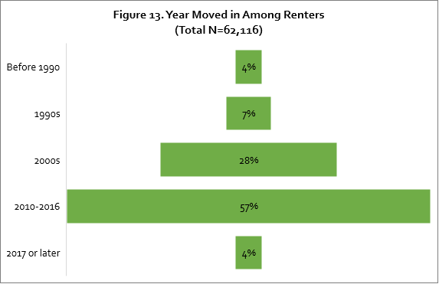

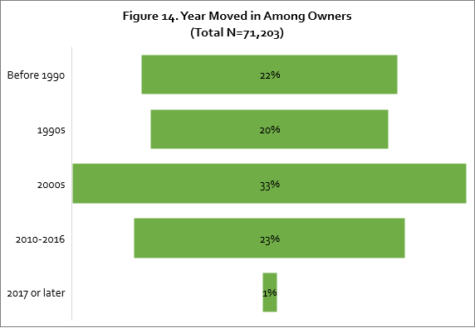

**Compton-East Compton Compared to LA County**

The following table compares the type of occupied units, when rentership was established by time period, and when homeownership was established by time period in Compton-East Compton with LA County.

|  |  |  |  |
| --- | --- | --- | --- |
| Table 4. Comparison of Housing Among Compton-East Compton and LA County | | | |
| Type of Occupied Units | | |  |
|  | **Compton-East Compton** | **LA County** | **Net Difference** |
| Owner | 53% | 45% | +8% |
| Renter | 47% | 55% | -8% |
| Established Renters by Time Period | | | |
|  | **Compton-East Compton** | **LA County** | **Net Difference** |
| Before 1990 | 4% | 3% | +1% |
| 1990s | 7% | 7% | 0% |
| 2000s | 28% | 18% | +10% |
| 2010-2016 | 57% | 40% | +17% |
| 2017 or later | 4% | 32% | -28% |
| Established Owners by Time Period | | | |
|  | **Compton-East Compton** | **LA County** | **Net Difference** |
| Before 1990 | 22% | 22% | 0% |
| 1990s | 20% | 20% | 0% |
| 2000s | 33% | 30% | +3% |
| 2010-2016 | 23% | 26% | -3% |
| 2017 or later | 1% | 2% | -1% |

**Key Takeaways**

* There is a greater rate of homeownership in Compton-East Compton (53%) compared to that of LA County (45%).
* About 75% of homeowners in Compton-East Compton moved there before 2010.
* The majority of renters (57%) moved into a residence in Compton-East Compton between 2010-2016.

1. Disaggregation of other communities available upon request
2. This number may vary now compared to when data was collected due to the economic impact of COVID-19.