**West Athens**

|  |
| --- |
| Overview |

This report describes the demographic profile of the West Athens community, defined by First5 LA’s Best Start initiative. Overall, the purpose of this report is to assist local councils in determining outreach and engagement goals to achieve representation of the current demographics of the community, as well as identify potential community needs.

All data in this report is from 2018 5-Year Estimates of the American Community Survey, an ongoing survey conducted by the U.S. Census Bureau. The geography of West Athens is defined by census tracts provided by First 5 LA as part of the initial planning in 2010. In order to provide some context, West Athens data was compared with that of LA County to highlight both potential inequities and a further need for systems change efforts.

|  |
| --- |
| Demographics of West Athens |

**West Athens Focus**

West Athens is a South LA Best Start community of 45,324 people across a total of 10 census tracts. The following charts show the composition of sex, age, race/ethnicity and education for West Athens residents.

**West Athens Compared to LA County**

The following table compares demographics of West Athens across sex, age, race/ethnicity and education with LA County.

|  |  |  |  |
| --- | --- | --- | --- |
| Table 1. Demographics Comparison Between West Athens and LA County: | | | |
| Sex | | |  |
|  | **West Athens** | **LA County** | **Net Difference** |
| Male | 46% | 49% | -3% |
| Female | 54% | 51% | +3% |
| Age | | |  |
|  | **West Athens** | **LA County** | **Net Difference** |
| Under 5 | 8% | 6% | +2% |
| 5-17 | 20% | 21% | -1% |
| 18-64 | 61% | 65% | -4% |
| 65+ | 11% | 14% | -3% |
| Race-Ethnicity | | |  |
|  | **West Athens** | **LA County** | **Net Difference** |
| Black | 47% | 8% | +39% |
| Latinx | 49% | 49% | 0% |
| White (Non-Latinx) | 2% | 26% | -24% |
| Asian | 1% | 15% | -14% |
| Latinx Origin (Top 3)[1] | | |  |
| Mexican | 66% | 76% | -10% |
| Salvadoran | 14% | 9% | -5% |
| Guatemalan | 11% | 6% | -5% |
| Citizenship | | |  |
|  | **West Athens** | **LA County** | **Net Difference** |
| U.S. Citizen, born in the U.S. | 74% | 65% | +9% |
| U.S. Citizen, naturalized | 9% | 18% | -9% |
| Not a U.S. Citizen | 16% | 17% | -1% |
| Education | | |  |
|  | **West Athens** | **LA County** | **Net Difference** |
| Less than High School | 28% | 21% | +7% |
| High School | 30% | 21% | +9% |
| Some College | 31% | 26% | +5% |
| Bachelor’s | 8% | 21% | -13% |
| Post-graduate | 4% | 11% | -7% |

**Key Takeaways**

* There is a larger proportion of Black residents in West Athens than that of LA County. In addition, there is a smaller proportion of White and Asian residents compared to that of the county
* Latinx and Black residents are the two largest groups in West Athens, respectively
* The majority of the Latinx community is Mexican (66%), with the next two groups being Salvadoran (14%) and Guatemalan (11%)
* The majority of West Athens are U.S. citizens born in the U.S. (74%) and at a greater proportion than that of LA County (65%)
* There are less naturalized U.S. citizens (9%) in the community than LA county (18%)
* There are more residents in West Athens that have achieved some form of college experience (31%) than in LA County (26%). However, fewer West Athens residents have earned a Bachelor’s degree (8%) and a Post-Graduate degree (4%) compared to LA County.

|  |
| --- |
| Economics of West Athens |

**West Athens Focus**

The following charts show the median income and ratio of income to federal poverty level for Compton-East Compton residents.

**West Athens Compared to LA County**

The following table compares the economics of West Athens across median income, poverty level, and unemployment with LA County.

|  |  |  |  |
| --- | --- | --- | --- |
| Table 2. Economics Comparison Between West Athens and LA County | | | |
| Median Income | | |  |
|  | **West Athens** | **LA County** | **Net Difference** |
| All Households | $43,766 | $72,797 | -$29,031 |
| White (Non-Latinx) | $53,583 | $92,457 | -$38,874 |
| Black | $39,257 | $52,136 | -$12,879 |
| Asian | $161,797 | $86,544 | +$75,253 |
| Latinx | $51,594 | $61,174 | -$9,580 |
| Poverty Level | | |  |
|  | **West Athens** | **LA County** | **Net Difference** |
| Below Poverty Level | 24% | 13% | +11% |
| At or Above Poverty Level | 76% | 87% | -11% |
| Unemployment | | | |
|  | **West Athens** | **LA County** | **Net Difference** |
| Unemployment Rate | 10% | 5% | +5% |

**Key Takeaways**

* The median income in West Athens is 60% that of LA County’s median income
* Among White, Black and Latinx racial groups in the community, the median income is lower than that of LA county
* There are a greater number of residents below the poverty level in West Athens (24%) versus LA County (13%).
* The unemployment rate in West Athens (10%) is twice that of LA county (5%)[2]

|  |
| --- |
| Families and Children of West Athens |

**West Athens Focus**

The following charts show the number of children under the age of 6 by familial arrangement, and the language spoken at home in the household for those under and over the age of 18 in West Athens.

**West Athens Compared to LA County**

The following table compares the total number of families with children under the age of 6, children under the age of 6 by family arrangement, and language usage in the household by age in West Athens with LA County.

|  |  |  |  |
| --- | --- | --- | --- |
| Table 3. Comparison of Families and Children Among West Athens and LA County | | | |
| Total Families with Children under 6 | | |  |
|  | **West Athens** | **LA County** | **Net Difference** |
|  | 864 | 183,314 | -- |
| Children under 6 by Family Arrangement | | | |
| Living with one parent | 65% | 37% | +28% |
| Living with two parents | 35% | 63% | -28% |
| Language Spoken in Household for Children 5-17 | | |  |
|  | **West Athens** | **LA County** | **Net Difference** |
| English | 47% | 45% | +2% |
| Spanish | 52% | 45% | +7% |
| Other | 1% | 9% | -8% |
| Language Spoken in Household for Adults 18+ | | | |
|  | **West Athens** | **LA County** | **Net Difference** |
| English | 54% | 43% | +11% |
| Spanish | 43% | 38% | -5% |
| Other | 3% | 19% | -16% |

**Key Takeaways**

* There is a greater proportion of children under the age of 6 living with one parent (65%) in West Athens than in LA County (37%).
* Spanish usage among children 5-17 (52%) and adults over the age of 18 (54%) is greater in West Athens than in LA County
* Other languages in the household besides English and Spanish are spoken at a much smaller proportion in West Athens than that of LA County.

|  |
| --- |
| Housing for West Athens |

**West Athens Focus**

The following charts show the type of housing of occupied units, the year moved in among renters, and the year moved in among home owners in West Athens.

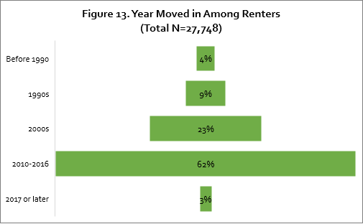

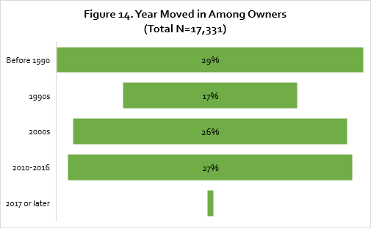

**West Athen Compared to LA County**

The following table compares the type of occupied units, when rentership was established by time period, and when homeownership was established by time period in West Athens with LA County.

|  |  |  |  |
| --- | --- | --- | --- |
| Table 4. Comparison of Housing Among West Athens and LA County | | | |
| Type of Occupied Units | | |  |
|  | **West Athens** | **LA County** | **Net Difference** |
| Owner | 38% | 45% | -7% |
| Renter | 62% | 55% | +7% |
| Established Renters by Time Period | | | |
|  | **West Athens** | **LA County** | **Net Difference** |
| Before 1990 | 4% | 3% | +1% |
| 1990s | 9% | 7% | +2% |
| 2000s | 23% | 18% | +5% |
| 2010-2016 | 62% | 40% | +22% |
| 2017 or later | 3% | 32% | -29% |
| Established Owners by Time Period | | | |
|  | **West Athens** | **LA County** | **Net Difference** |
| Before 1990 | 29% | 22% | +7% |
| 1990s | 17% | 20% | -3% |
| 2000s | 26% | 30% | -4% |
| 2010-2016 | 27% | 26% | +1% |
| 2017 or later | 1% | 2% | -1% |

**Key Takeaways**

* There is a lower rate of homeownership in West Athens (38%) compared to that of LA County (45%).
* About 27% of homeowners in West Athens moved there before 2010
* The majority of renters (62%) moved into a residence in West Athens between 2010-2016

1. Disaggregation of other communities available upon request
2. This number may vary now compared to when data was collected due to the economic impact of COVID-19